AZURE DEVOPS

**Aim: -** To enable back up on-premises file and folder and virtual machine (VM) to the azure cloud.

# To enable virtual machine (VM) backup on Azure Cloud

Create and configure backup in virtual machine.

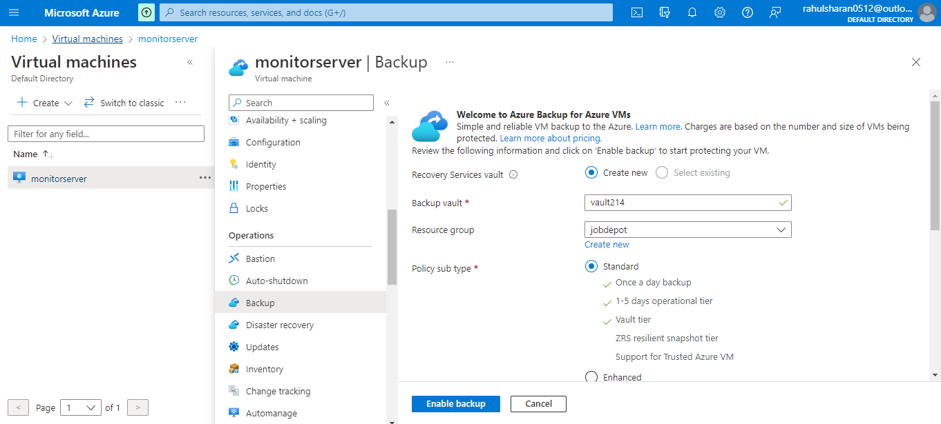

Create policy in backup.

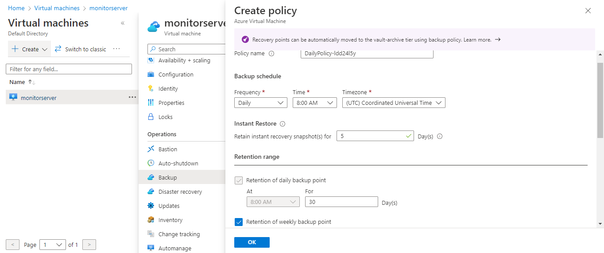

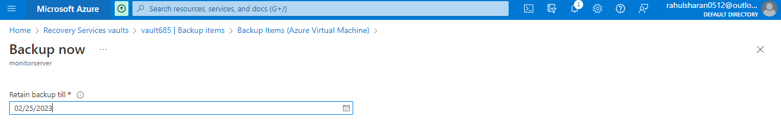

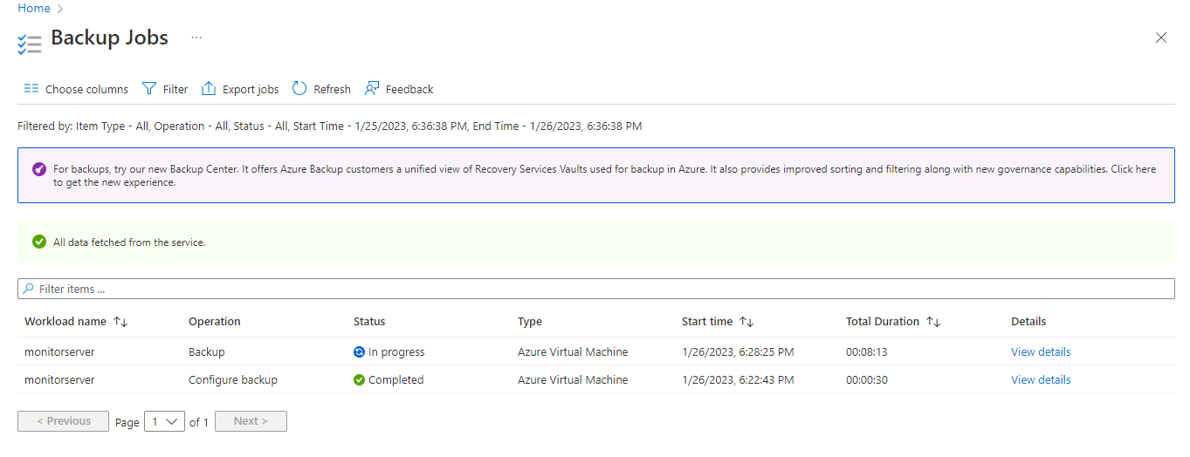

Create restore in virtual machine

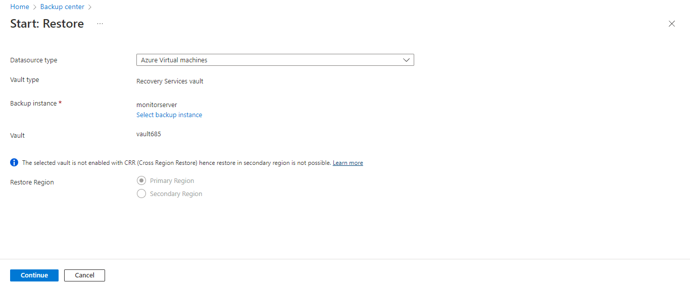

Create disaster recovery to replicate the Source region (Central India)  
 target region (East US) in virtual machine.

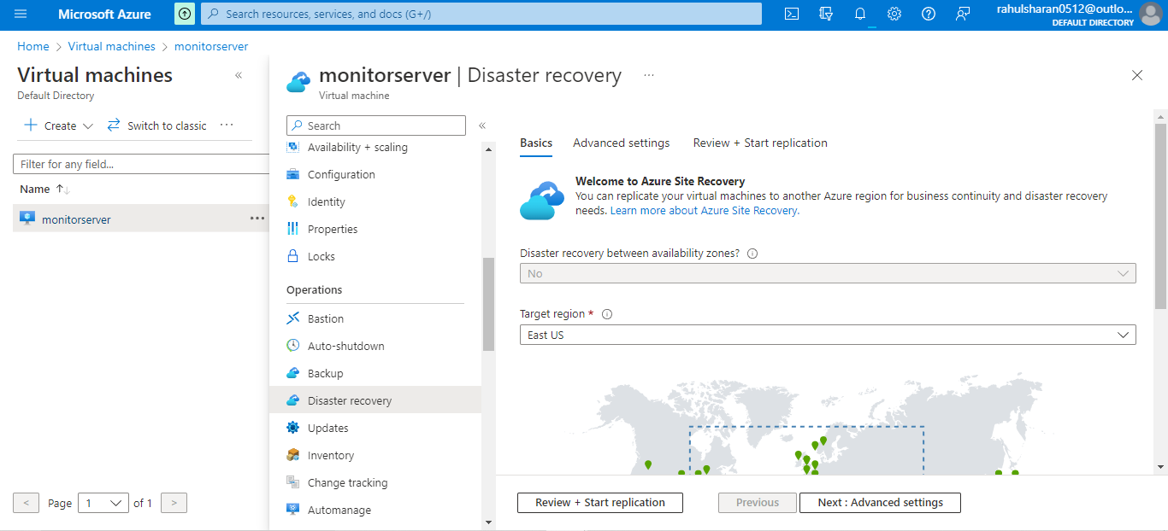

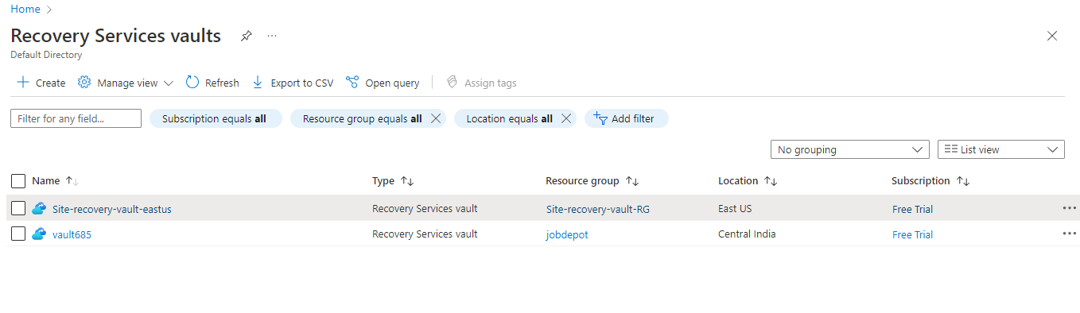

# 

# To enable back up on-premises file and folder to the azure cloud

Create Recovery service vault (RSV).

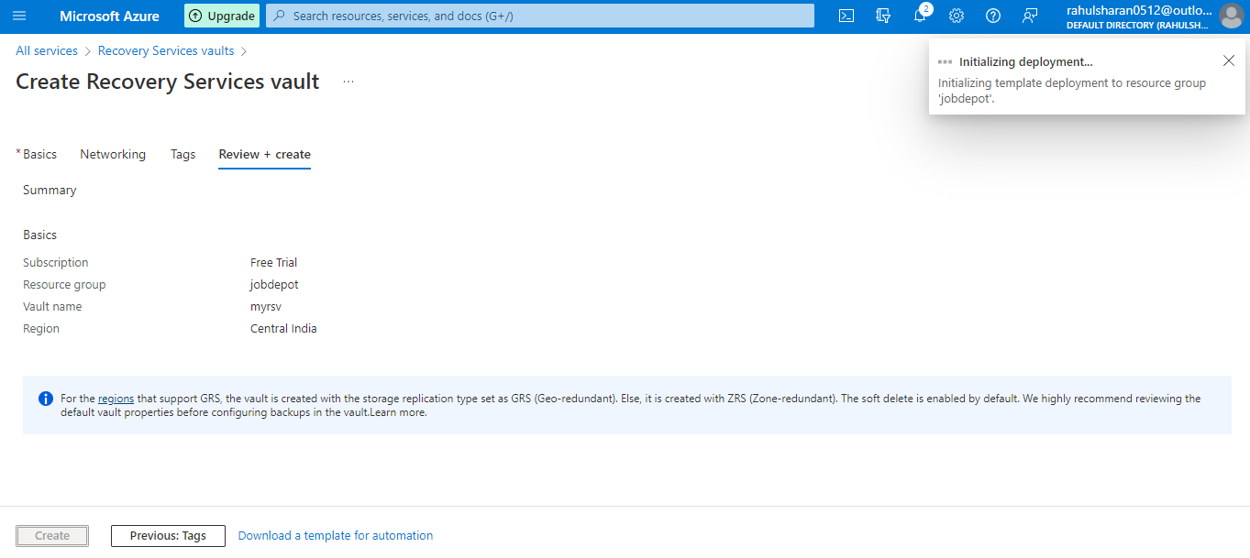

Create file and folder backup in on-premises.

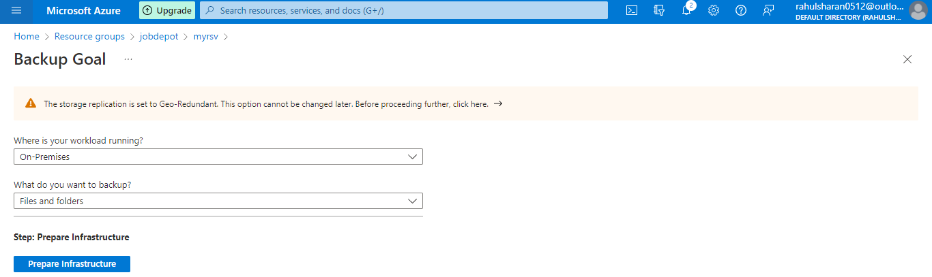

Download, Install and configure Microsoft azure backup (Recovery service agent).

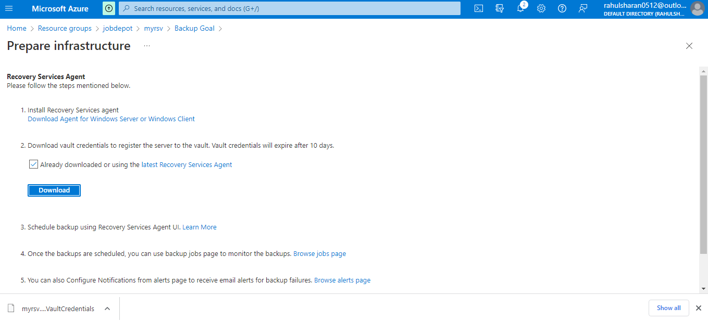

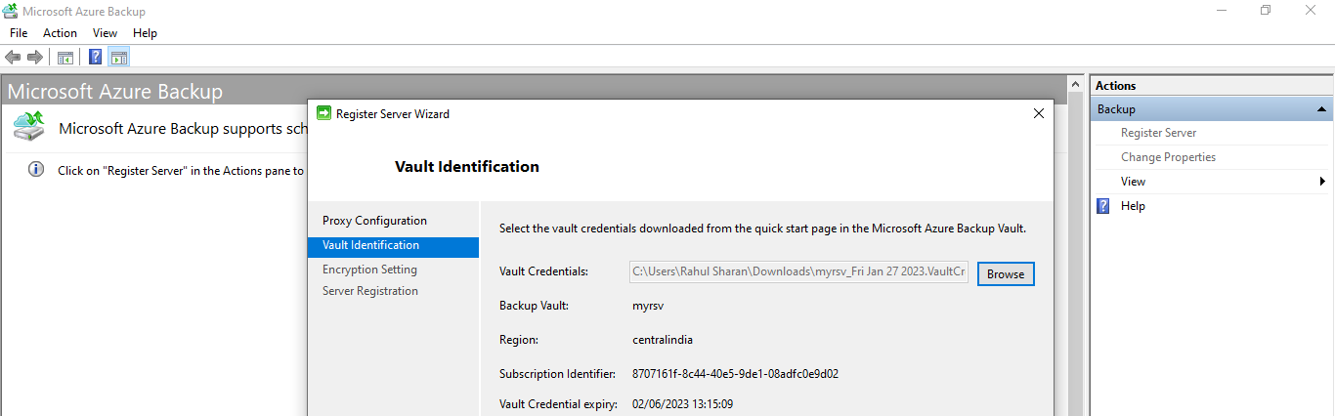

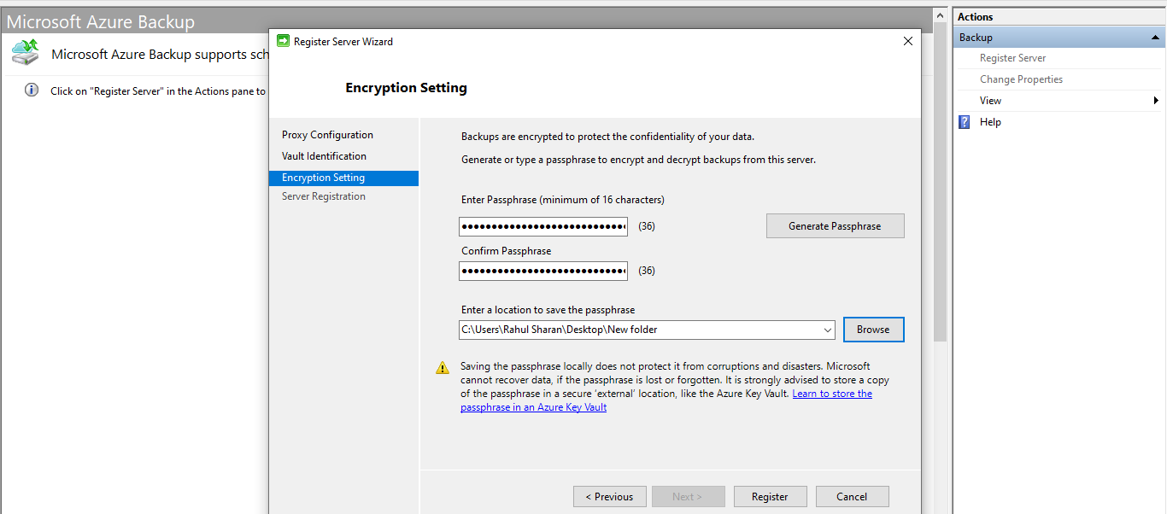

Microsoft azure backup server registration done.

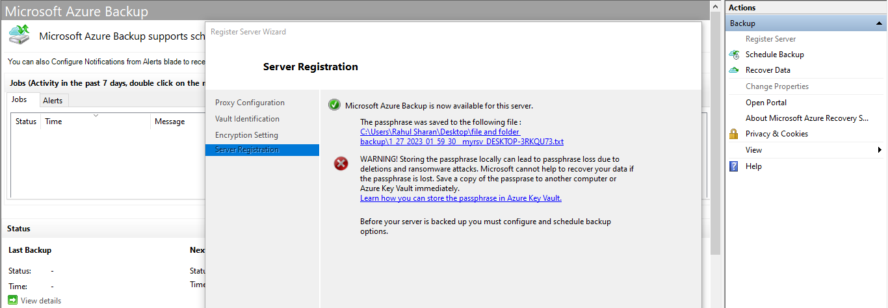

Schedule backup in Microsoft azure backup.

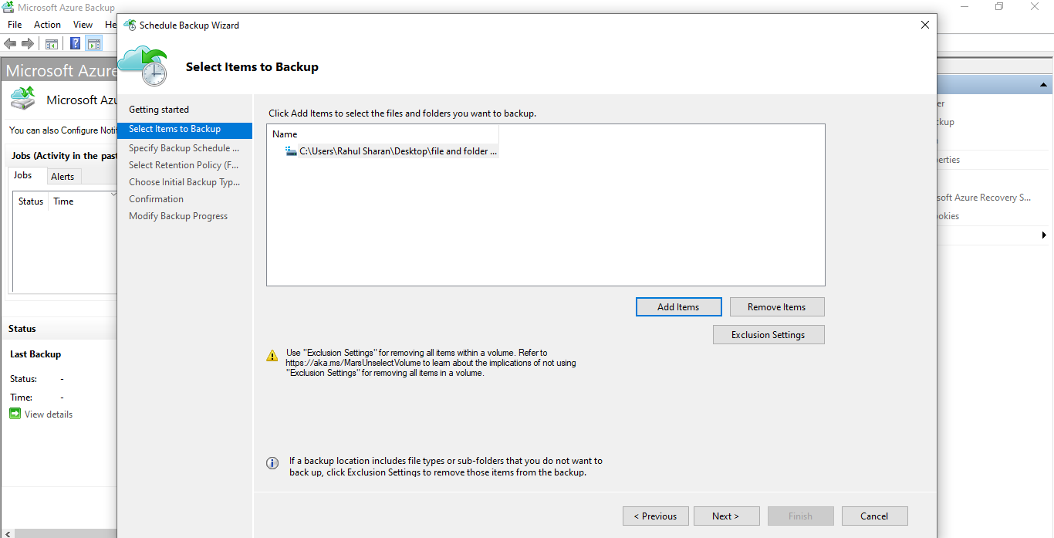

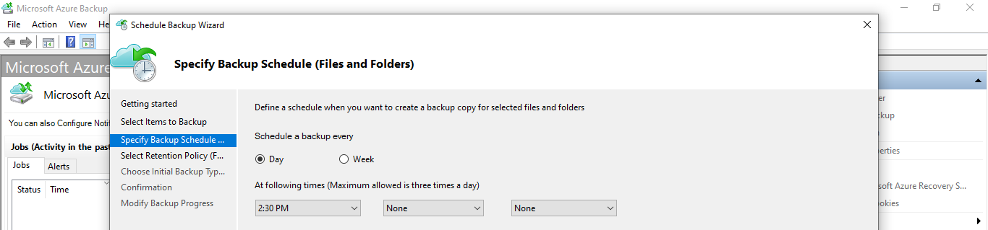

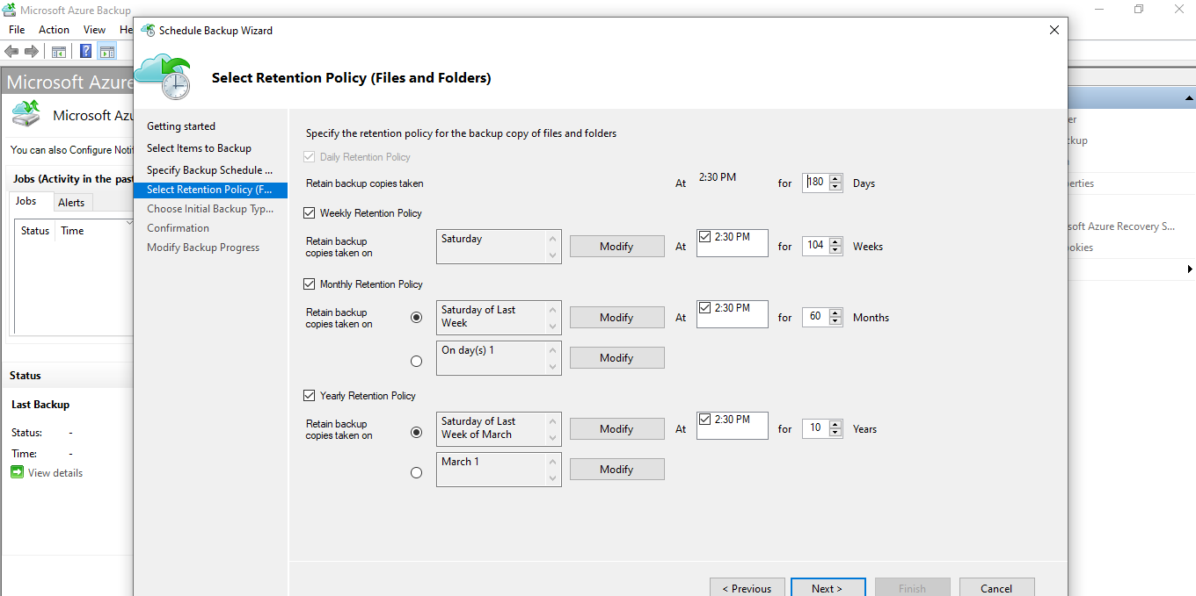

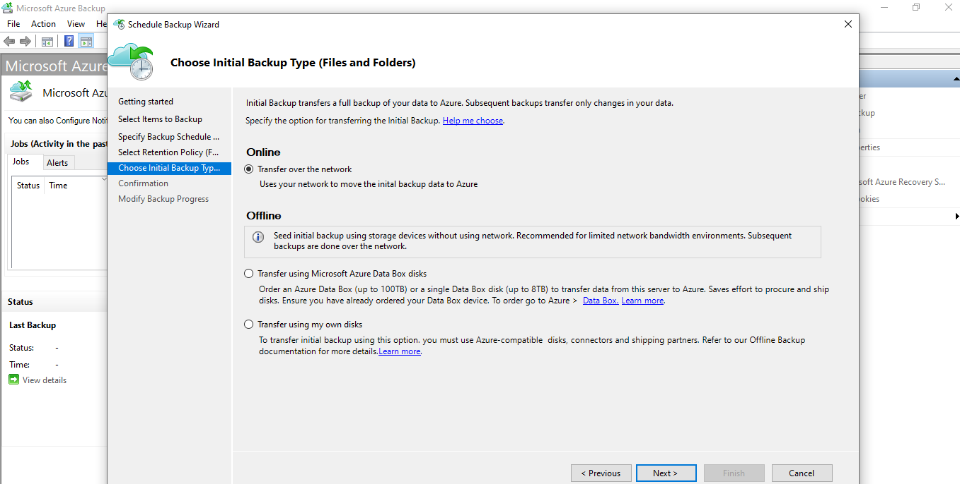

Successfully created a backup schedule.

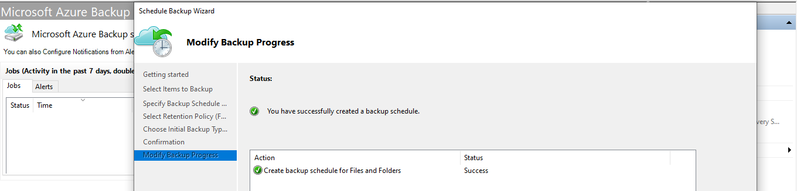

Create a backup in Microsoft azure.

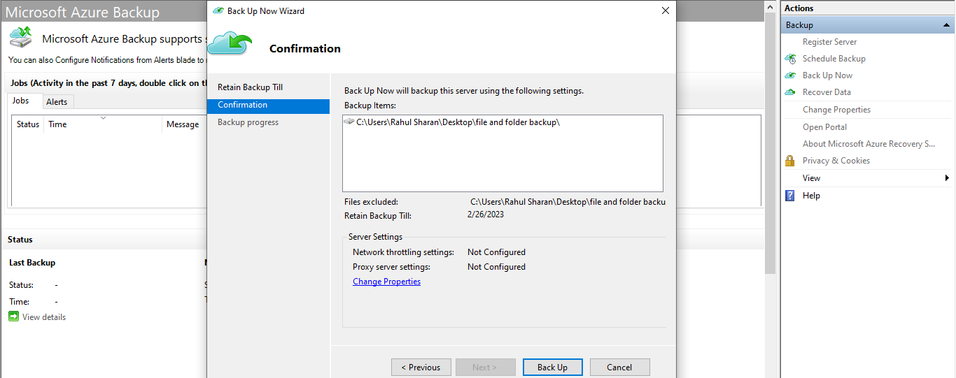

Successfully created file and folder backup.

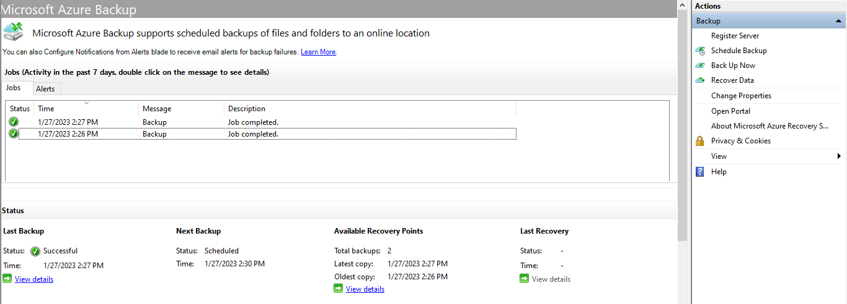

Restore file and folder in Microsoft azure.

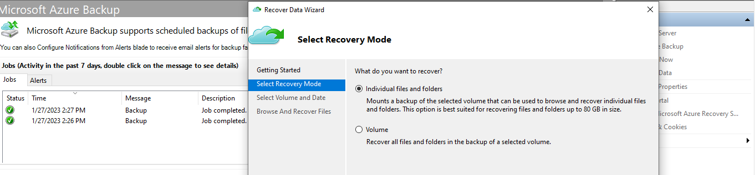

Successfully restored file and folder in Microsoft azure.

